**PAS**

**To:** Dr. Matt Bohm

**From:** PAS

**Project:** Plasma Arc Speaker

**Subject:** Concept Variant 7

**Date:** March 4, 2011

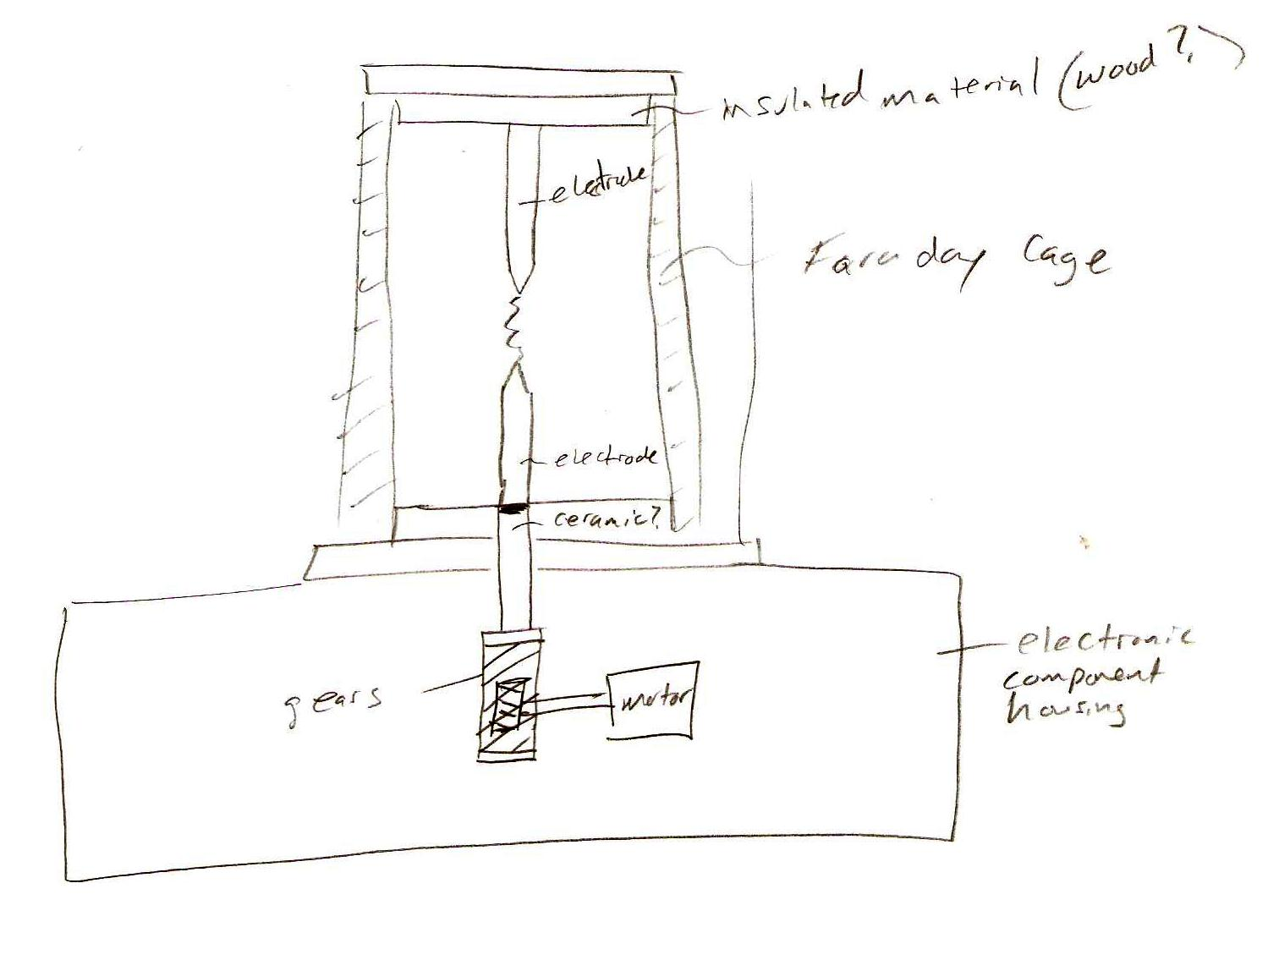

CV 7 consists of an electrical component housing on the bottom.  The electrodes are located vertically above the housing and are insulated with wood or a ceramic material on the top and bottom, as well as being surrounded by a Faraday cage.  The bottom electrode is connected to a motor which lowers and raises the electrode for spark initiation and optimization.